Power BI - A Complete Introduction

Power BI

Power BI is a collection of Tools or Software’s provided by Microsoft Corporation for performing Business Intelligence Activities.
Power BI is a Self Service, Cloud Based Reporting Software (OR) Data Visualization Software (OR) Data Analytics Software (OR) Business Intelligence Software.
To Perform Business Intelligence there are “N” numbers of Business Intelligence Tools/Software’s both Traditional and Self serviced in the Market from Different Vendors, below are the popular among them and their service provider.

BI Tool | Service Provider
Power BI | Microsoft
Tableau | Tableau Software
QlikView | Qlik
Qlik Sence | Qlik
MSBI | Microsoft
Microstrategy | Microstrategy Corporation

We have two types of BI tools in market
- Traditional BI
- Self-Serviced BI
In recent years, we observe that there has been an evolutionary shift from legacy, on premise traditional Business Intelligence (BI) solutions to cloud-based, self-serviced BI.
Traditional BI
Traditional BI has been around for years and often requires a high-level technical skill to implement, administer and maintain the solution. Another characteristic of traditional BI is that it requires the solution to be housed on premise. For growing companies, this is a costly and ineffective solution. Additionally, since traditional BI is typically a technical product, it’s difficult for business users to have access to it.
Fundamental characteristics of Traditional BI
- Traditional Tools offers a broad range of features which allow companies to cover a wide spectrum of reporting types and an array of use cases.
- Requires a high level of technical expertise, users rely significantly on IT to perform even the most basic functions like building reports. As a result, user adoption rates may suffer.
- Requires IT to have SQL query skills or learn a proprietary query language in order to implement- which drives up cost and adds to the time required to deploy the solution.
Self Service BI
Self-service BI is a form of Business Intelligence in which end users are empowered to independently satisfy their own information needs. With self-service BI, non-technical professionals can generate their own reports, run their own queries, and conduct their own analyses, without the assistance of IT staff.
Fundamental characteristics of Self-Service BI
- Business users are able to access the real-time data they want and quickly generate results without the need for technical expertise. Often, no coding skills are required.
- Self Service BI’s upfront costs, total cost of ownership (TCO) and total cost of change (TCC) are significantly less than Traditional BI’s costs.
- User adoption is typically greater with Self Service BI than with Traditional BI because it’s easier for the non-technical business user to understand and leverage.
Cloud Based
- Cloud-based is a term that refers to applications, services or resources made available to users on demand via the Internet from a cloud computing provider's servers.
- With the help of Power BI Service you can analyze your data anywhere from the world with the help of internet.
On-Premise BI
- On-Premises BI software which is installed locally, on a company’s own computers and servers.
- Power BI Report Server is a solution that customers deploy or install on their own premises for publishing, sharing and managing Reports.
- Reports shared from Power BI Report Server can be accessed within the Network only.
Reporting
- Presenting the Data in a Structured Format we call it as Reporting. With the help of Power BI we can present the Data in a Structured Format hence we called Power BI Software as a Reporting Software.

Data Visualization
- Presenting the Data in the form Graphs, Charts, Maps etc., we call it as Data Visualization (OR) Graphical Representation of Data we call as Data Visualization. With Power BI Software we Can Present the Data in a Graphical Format hence we call Power BI Software as Data Visualization Software.
Data Analytics
- Performing the Analysis on the Data we call it as Data Analytics. With the Help of Power BI Software we can perform Analysis on huge Volumes of Data hence we call Power BI Software as Data Analytics Software.
Business Intelligence
- Business Intelligence is a Process which Converts Business Data into Actionable Information.
- Business Intelligence Process helps Business Managers to make more informed business decisions.
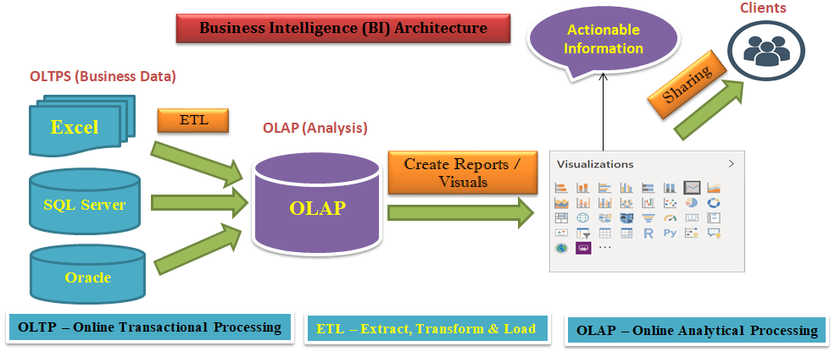

When you go as any BI Developer Clients will provide the OLTP(S) which Contains Business Data and ask you to perform the Analysis. It is not recommended to perform the Analysis Directly on top of OLTP System. As a BI Developer First we need to create an OLAP System where we need to bring data that is required for Analysis. To move the Data from OLTP Systems to OLAP System we need to use ETL Tools. Once Data is there in the OLAP we need to Start Performing the Analysis. Create the Reports and Visuals on Top of OLAP and Finally Share them with Clients.
To Perform this Business Intelligence Activities Microsoft Provided Power BI Software.
Power BI is the not the Name of Single Software. It’s the Name for Suite of Software’s which we used for performing Business Intelligence (BI) Activities.
Power BI Software’s / Tools / Products
- Power BI Desktop
  - Power Query
  - Power Pivot
  - Power View
- Power BI Service
- Power BI Report Server
- Power BI Mobile
Power BI Desktop
- Power BI Desktop is a tool to Connect to, clean, model, and visualize your data.
- With Power BI Desktop, you can connect to different Data Sources to Extract the Data, Transform the Data if required, Model the Data (Data Modeling) and visualize the Data in different ways.
- Power BI Desktop is the combination of below software’s
  - Power Query
  - Power Pivot
  - Power View

Power Query
- Power Query is used for Data Extraction, Transformation and Loading. It’s an ETL Software in Power BI.
- With the help of Power Query, we will connect to the different Data Sources to Extract the Data, Transform the Data and then we will load the Data into Power Pivot.
- The Power Query Software comes with a graphical tool “Power Query Editor” and a formula language M (Mashup) Language to Transform the Data.
- With the help of predefined functions in the graphical tool we can transform the data in Power Query. However, Power Query can be programmed to create custom functions. This gives you seemingly unlimited potential to transform your data in just about any way possible.
- The formula language we used in Power Query is the M (Mashup) language to create the custom functions.
- Power Query can load the result set into Power Pivot model.
- Power Query not only makes all these tasks easier, but it also records your steps.
Power Pivot
- Power Pivot is an In-Memory Columnar Database where we store the Data that is required for Analysis Purpose. Power Pivot is used for preparing an OLAP / Dataset.
- Power Pivot is the place where we place the transformed data that is loaded by Power Query for Data Modeling.
- Power Pivot works on xVelocity In-Memory based tabular engine. Current Name for Power Pivot “In Memory” is xVelocity previously they used to call as Vertipaq Engine.
- The In-Memory engine gives Power Pivot super-fast response time and the modeling engine would provide you a great place to build relationships through Entities, build your Star Schema, Create New Columns, New Measures/Quick Measures and New Tables, and so on.
- To Enhance the Data Model Power Pivot uses Data Analysis eXpression language (DAX) for building New Columns, New Measures/Quick Measures & New Tables.
- DAX is a powerful functional language which contains multiple functions that are helpful to perform the Data Analysis extensively as per the Client needs by creating new information Like New Columns, New Measures/Quick Measures & New Tables.
Power View
- Power View is used for Data Visualization.
- With Power View you can create interactive charts, graphs, maps, and other visuals that bring your data to life.

Power BI Desktop Process Flow
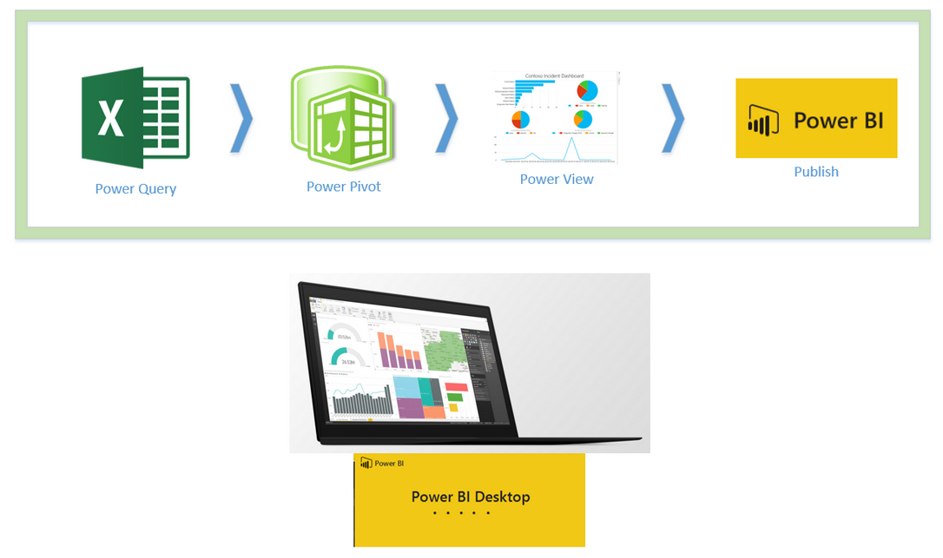
- Power BI Desktop as mentioned above is an editor for three components→ Power Query, Power Pivot, and Power View.
- Power Query connects to data sources and mash up the data with a formula language, the result set of Power Query will be loaded into a tabular model which is Power Pivot.
- Power Pivot can set the relationships and allow you to create New Columns, New Measures / Quick Measures and New Tables using DAX Language and set the Data Model as you want.
- Then Power View connects to the Data Model and Visualizes the data with different charts and visualization elements.
- Power BI Desktop has everything in one editor, and this makes it an easy to use tool.
- You can solve very complex challenges with Power BI Desktop only because of its underlying components.

Power BI Service
- Power BI Service is cloud based solution which is managed by Microsoft Corporation for publishing, sharing and managing Reports and Dashboards.
- Reports or Dashboards shared from Power BI Service can be accessed anywhere from the world.
- You can view the Reports or Dashboards that are shared with you with the help of web browsers or Mobile Application (Power BI Mobile).
Power BI Report Server
- Power BI Report Server is a solution that customers deploy or install on their own premises for publishing, sharing and managing Reports.
- Reports shared from Power BI Report Server can be accessed within the Network only.
- You can view the Reports that are shared with you with the help of web browsers or Mobile Application (Power BI Mobile).
Power BI Mobile
- Power BI Mobile is a mobile application which is used to see the Reports and dashboards shared with us by logging with our server credentials.
- Power BI Mobile App is available for Android, Apple, and Windows Phone, simply download it from Google Play (Android), or App Store (Apple), or Windows Store (Windows Phone) and install.
- After the installation login with your server credentials (username and password), and you’ll see Reports and Dashboards shared with you.

The Flow of Work in Power BI / Power BI Architecture
A common flow of work in Power BI is
- Bring data into Power BI Desktop, and create a report.
- Publish to the Power BI service or Power BI Report Server, where you create new visualizations or build dashboards.
- Share your dashboards with others, especially people who are on the go.
- View and interact with shared dashboards and reports in Power BI Mobile apps (Windows phones and tablets, as well as for IOS and Android devices).

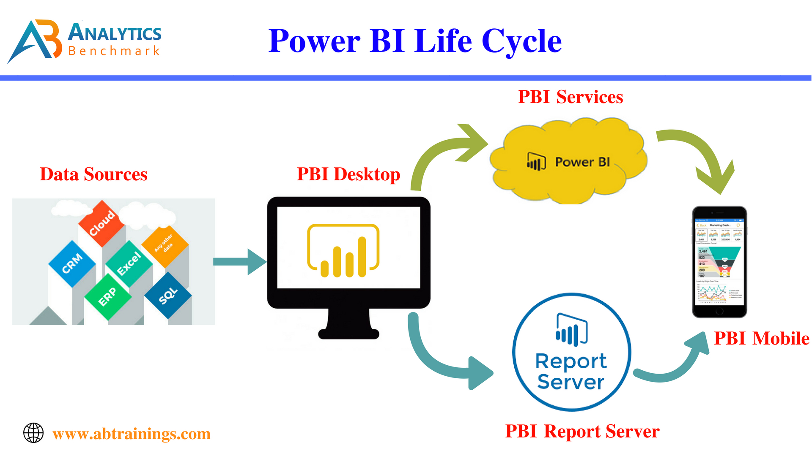

Power BI Reporting life cycle or BI Life Cycle
- Preparing the data and Loading into Reporting Tool → Power Query
- Data Modeling and defining Metrics → Power Pivot
- Report generation → Power View
- Creating Dashboards, Sharing & Admin Activities →Power BI Service or Power BI Report Server
- Viewing Reports & Dashboards → Mobiles and Web Browsers.

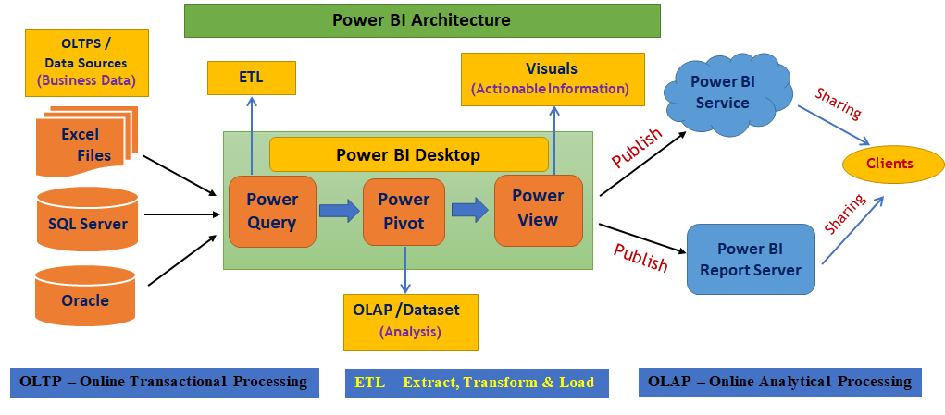

A Brief History of Power BI
The tools in the Power BI are not new into the market. Let us see the history of Power BI.
- Power Query is a free add-in in Excel 2010 and 2013 and it is inbuilt in Excel 2016.
- Power Pivot is a free add-in in Excel 2010 and 2013 and it is inbuilt in Excel 2016.
- Power View is a free add-in in Excel 2013 and it is inbuilt in Excel 2016.
- Power BI Service is released on Jan 2015.
- Microsoft combined Power Query, Power Pivot and Power View as Power BI Desktop and released on July 2015.
- Power BI Report Server was released on June 2017.

